CMPE321

Project 1

Part 1

Ahmet Fırat Gamsız – 2020400180

Yunus Emre Özdemir - 2020400153

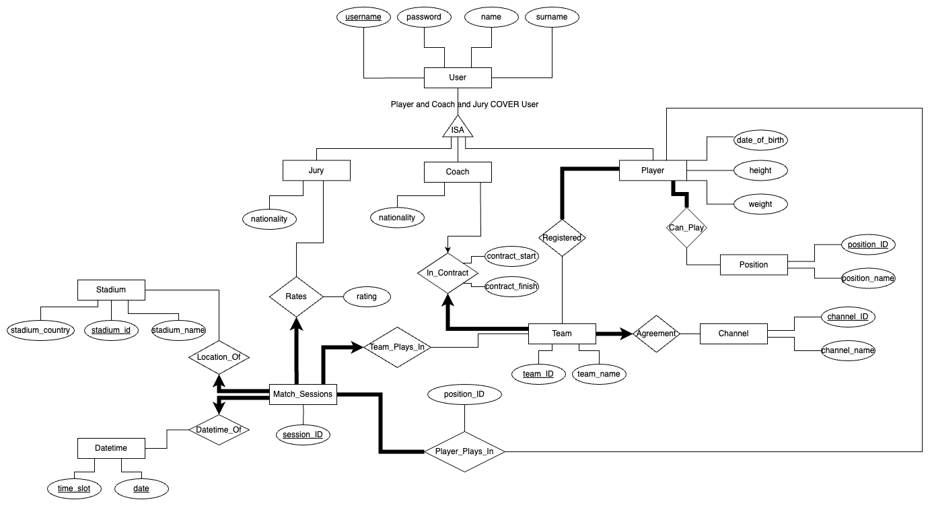



For readability both vertical and horizontal versions of the diagram included

Important: Player and Coach and Jury COVER User

Discussion:

What we did:

- We started with User entity and add its attributes. Jury, Coach and Player are inheriting the User entity so we used an ISA relationship between those and User. Then we continued with Player entity and add included its attributes. Since every play has one more positions they can play, we added a Position entity and connected with Can_Play relation. Also since Player has to have at least one position this is a participation constraint so we used thick line.

- We included Jury and Coach entities with nationality attributes. We created a Team entity and with a Agreement relation we connected it to a Channel entity. This relationship’s Team part is a thick arrow since every channel has to agree with exactly one channel (participation and key constraints). Team entity also relates to Player with Registered relation. This relation’s Player side is thick because Player must play in at least one team (contribution constraint). Coach has a relationship with Team called contract. This relationship holds contract start and finish times too. Coach connected to this relationship with an arrow since a coach can only be in contract with one team. Team is connected with a thick arrow since team has to have exactly one coach (participation and key constraints).

- We have a Match_Session entity that relates to most of the entities. First relationship is with Player and it is called Player_Plays_In. Match sessions connects with a bold line since every match must have at least one player in the players list. This relationship also has position_ID attribute. This attribute doesn’t have any effect here but will be useful in second part. Team_Plays_In relation is between Match_Sessions with a thick arrow and Team. The reason of that is every match must be played exactly by one team. Match_Sessions connect to Stadium with Location_Of relationship and to Datetime with Datetime_Of relationship. Relationships leaving Match_Sessions are bold arrows since each match can be played in exactly one stadium and one date and timeslot. Because of that Datetime entity has date and time_slot attributes as key.

What we couldn’t do:

- We couldn't show that some attributes shouldn't take a NULL value, such as "Each coach **must** have only one nationality." constraint.

- Our ER design doesn't prevent players playing in matches where there are time conflicts.

- We were able to make sure that players play in only one position in a match session, but we couldn't prevent players from playing in a position they can't play (is registered).

- We couldn't implement the constraint "Juries can't edit/change their ratings."

- We couldn't implement the constraints related to the match session overlaps.

- We can't check if a team plays in different match sessions in different stadiums at the same date and time.

- We can't check if a player that plays in a match is registered in the team that plays in that match.

- In the ER design, Player_Plays_In relationship has a position_ID attribute. This attribute is supposed to be a foreign key that references the position_ID attribute of the Position entity, we couldn't show this.